Aniket Kanodia

Kanodiaaniket979@gmail.com

Abstract

In this document we will find insights about version control, its application and its various types.

Version control

🡺What is version control?

Version control is a system that records changes to a file or set of files over time so that you can recall specific versions later.

🡺Why we need version control?

1. Helps to keep track of any change done to project.
2. Provides of with option to revert changes made if we screwup making changes to project.

🡺What are different types of version control?

Different types of version control are-

1. Local Version Control System
2. Centralized Version Control System
3. Distributed Version Control System

🡺Explain Local Version Control System.

**Local Version Control System:-** Many people keep track of their file by locally copying them to new directory(preferably naming them with time stamps). But sometimes this practice is a trouble because it is difficult to keep track of changes made in the project.

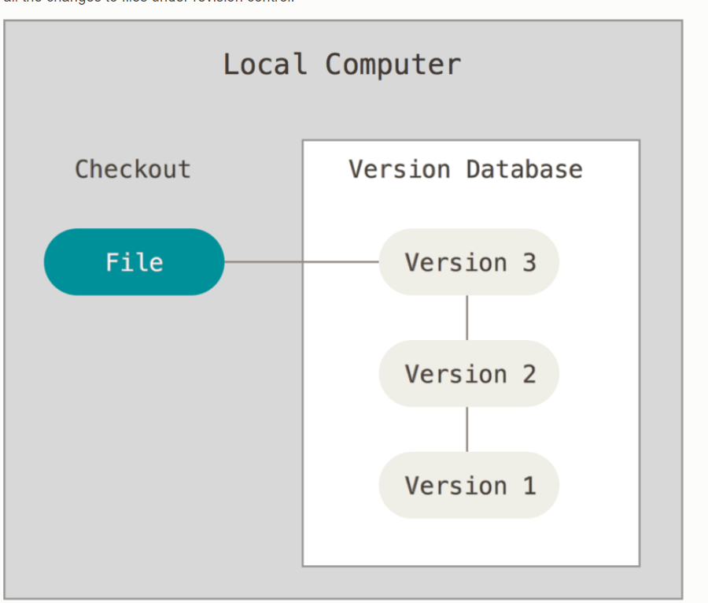

🡺Explain centralized version control system.

**Centralized Version control:-** These systems (such as CVS, and Perforce) have a single server that contains all the versioned files, and a number of clients that check out files from that central place.

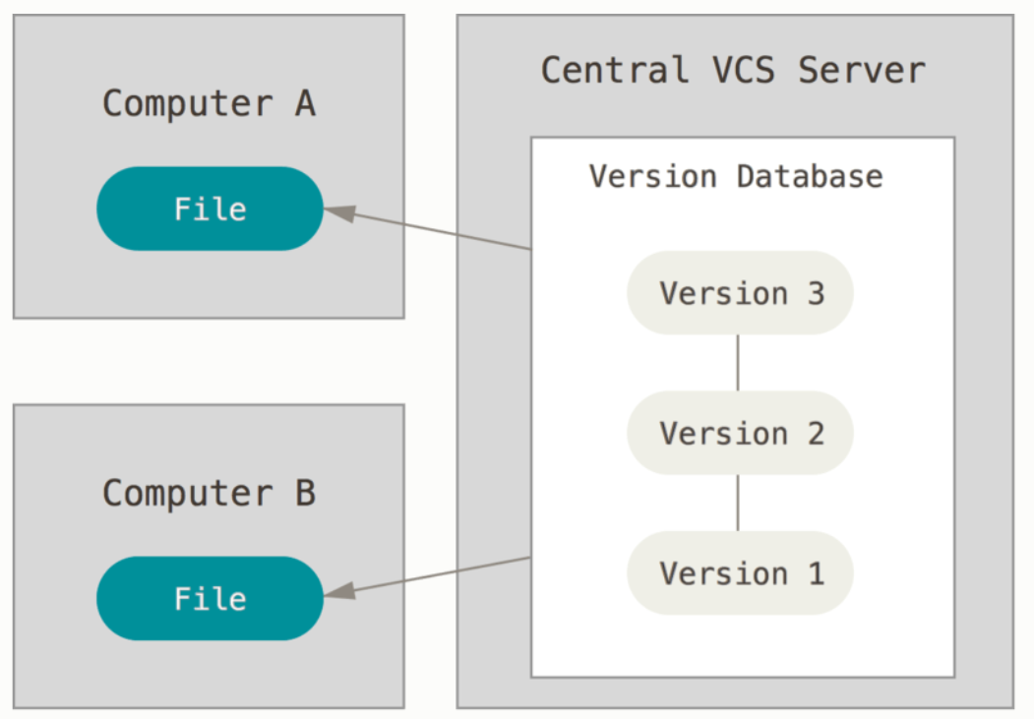

🡺Explain distributed system control.

**Distibuted System Control:-** In a DVCS (such as Git, Mercurial, Bazaar or Darcs), clients don’t just check out the latest snapshot of the files; rather, they fully mirror the repository, including its full history

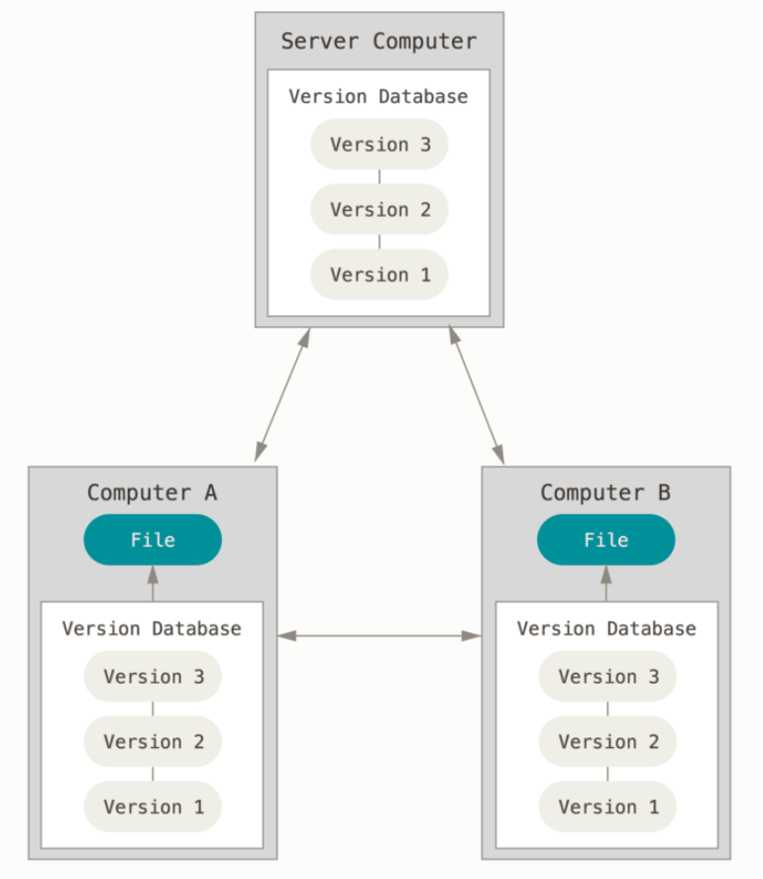

The advantage of distributes system control is  if any server dies, and these systems were collaborating via that server, any of the client repositories can be copied back up to the server to restore it.

🡺What is subversion?

**SUBVERSION:-**  Apache Subversion is an open-source software version and revision control system under the Apache license. It managed files and folders that are present in the repository. It can operate across the network, which allows it and used by people on different computer .we can say that a repository is like an ordinary file server which allows it to be used by people on a different computer.

Features of SVN:

* Directories are versioned
* Copying, deleting, and renaming.
* Free-form versioned metadata .
* Atomic commits.
* Branching and tagging.
* Merge tracking.
* File locking.